**Finding the best place for store owners**

Dahye Lee

August 18,2020

1. Introduction

When locating a store, the store owners compare how many stores in the same industry are nearby.

2. Data

We decided to use regularly spaced grid of locations, centered on city center, to define our neighborhoods. Following data sources will be needed to extract/generate the required information. The number of restaurants nearby the city will be collected by Foursquare API

3. Methodology

The number of shops of the same industry is counted around the area based on the designated area and industry, and the area with the lowest number is recommended. Set the area radius to a circle of a certain size and move the circle to count the number of stores of the same industry in the circle.

4. Result

We select the regions near the location that a user inputs. After counting the stores of the same industry located around each region, the regions with the smallest number were extracted and the region closest to the center was selected.

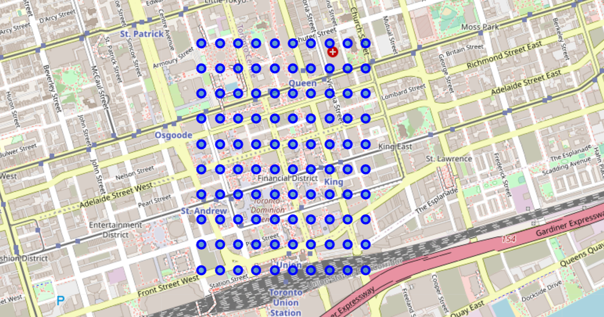

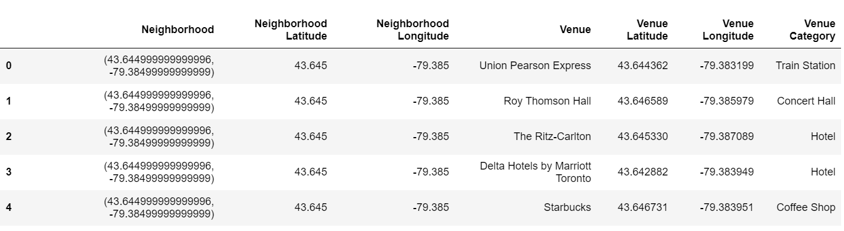

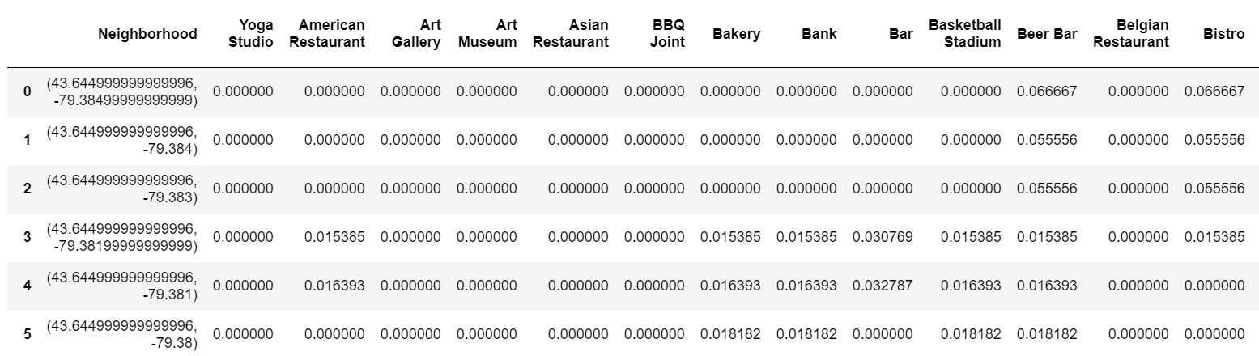

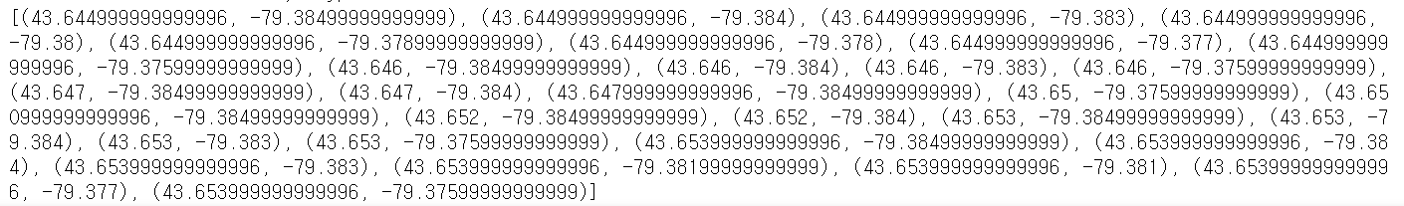



5. Discussion

We used Toronto’s latitude and longitude. Few regions which American restaurants are not located in existed. So we selected the closest region from the center of Toronto. It is helpful for finding out distribution of each industry.

6. Conclusion

When selecting a location for a store for the first time, it can help to check the distribution of the same industry and to select a good location for commerce.